**DATA ANALYST SQL PROJECT ( HR DATA SET)**

**Create Table**

create table hrdata

(

emp_no int8 PRIMARY KEY,

gender varchar(50) NOT NULL,

marital_satus varchar(50),

age_band varchar(50),

age int8,

department varchar(50),

education varchar(50),

education_field varchar(50),

job_role varchar(50),

business_travel varchar(50),

employee_count int8,

attrition varchar(50),

attrition_label varchar(50),

job_satisfaction int8,

active_employee int8

)

**Import Data in Table Using Query**

COPY hrdata FROM 'C:\Users\sachi\OneDrive\Desktop\SQL projects\hrdata.csv' DELIMITER ','

CSV HEARDER;

**Show Data in table**

Select * from hrdata

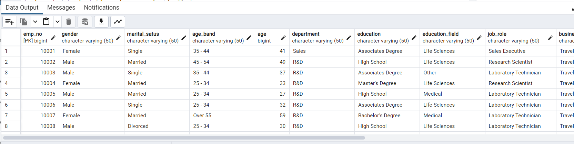

**Employee Count**

select sum(employee_count) as employee_count from hrdata

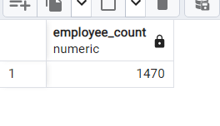

**Attrition Count**

select count(attrition) from hrdata where attrition = 'Yes'

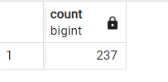

**Attrition Rate**

select round(((select count(attrition) from hrdata where attrition = 'Yes')

/sum(employee_count))*100,2)

from hrdata

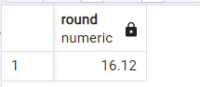

**Active Employee**

select sum(employee_count)-(select count(attrition) from hrdata where attrition ='Yes')

from hrdata

***or***

select (select sum(employee_count) from hrdata) - count(attrition) as active_employee from hrdata

where attrition='Yes';

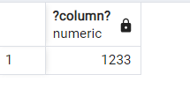

**Average Age**

select round(avg(age),0) as age from hrdata

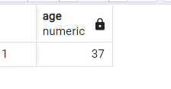

**Attrition By Gender**

select gender , count(attrition) from hrdata where attrition = 'Yes'

group by gender

order by count(attrition) DESC

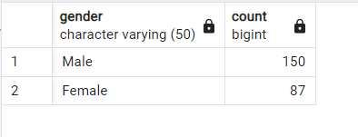

**Department wise Attrition**

select department , count(attrition),

round((cast(count(attrition) as Numeric)/(select count(attrition) from hrdata where attrition = 'Yes'))*100,2)

from hrdata

where attrition = 'Yes'

group by department

order by count(attrition) DESC

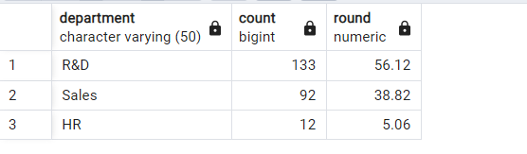

**No of Employee by age group**

select age , sum(employee_count) from hrdata

group by age

order by age

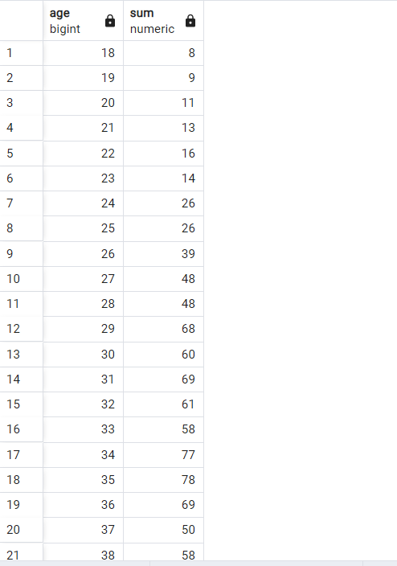

……………………………………………..

**Education Field wise Attrition**

select education_field , count(attrition) from hrdata

where attrition = 'Yes'

group by education_field

order by count(attrition) desc

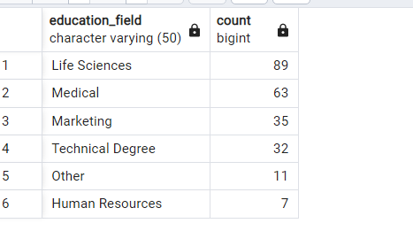

**Attrition Rate by Gender for different Age Group**

select age_band , gender , count(attrition),

round((cast(count(attrition) as numeric )/

(select count(attrition) from hrdata where attrition = 'Yes'))*100,2) as pct

from hrdata

where attrition = 'Yes'

group by age_band , gender

order by age_band , gender

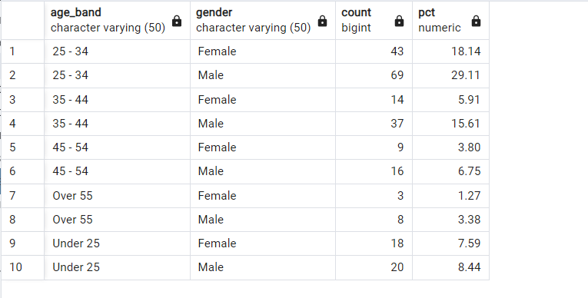

**Job Satisfaction Rating**

create extension if not exists tablefunc;

select *

from crosstab(

'select job_role , job_satisfaction , sum(employee_count)

from hrdata

group by job_role , job_satisfaction

order by job_role , job_satisfaction'

) as ct(job_role varchar(50), one numeric , two numeric , three numeric , four numeric)

order by job_role;

